A Practical activity Report submitted

for Engineering Design Project-II (UTA-024)

by

**Pulkit Arora 102103267**

**Submitted to**

**Dr. ...............................**



**DEPARTMENT OF ELECTRONICS AND COMMUNICATION ENGINEERING**

**THAPAR INSTITUTE OF ENGINEERING AND TECHNOLOGY, (A DEEMED TO BE UNIVERSITY), PATIALA, PUNJAB**

**INDIA**

**Jan-May 2023**

**Experiment: 2**

**Objective:**

1. To draw a schematic diagram of IR sensor module circuit (required to move Buggy module on a predefined the path) using CAD tool (Eagle).
2. To design a printed circuit board layout of IR sensor module circuit using CAD tool (Eagle).

**Software Used:** Eagle Software

**Components Used:**

|  |  |  |  |  |
| --- | --- | --- | --- | --- |
| **Sr. No.** | **Name of Component** | **Value** | **Specifications** | **Quantity** |
| 1. | Resistor | 330 Ω | Carbon resistor with 5% Tolerance | 4 |
| 2. | Resistor | 10k Ω | Carbon resistor with 5% Tolerance | 2 |
| 3. | SFH482 |  | Infrared Light Emitting Diode | 2 |
| 4. | BPX65 |  | Pin Photo Diode | 2 |
| 5. | LED3MM |  | Light Emitting Diode | 2 |
| 6. | LMV358MM |  | Low voltage Rail-to Rail Op-Amp | 1 |
| 7. | MTA02-100 |  | AMP connector | 1 |
| 8. | PT-10 |  | Potentiometer | 2 |

**Theory:**

1. **Resister:** Resistor are electronic components which do not allow charge to freely pass through them. It is used to limit or regulate the flow of current in electric circuits. Based on different processes and materials, fixed resistors may be divided into solid core resistance, special resistor, metal wire wound resistor, and film resistors.

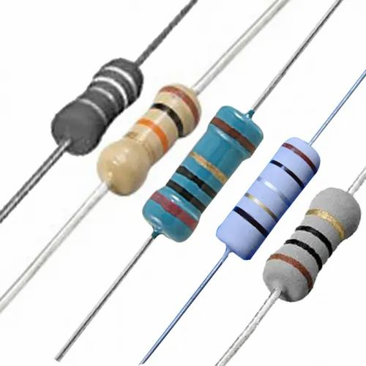

**Fig 2.1:** Resistors

1. **SFH482:** An IR LED (infrared light emitting diode) is a solid-state lighting (SSL) device that emits light in the infrared range of the electromagnetic radiation spectrum. IR LEDs allow for cheap, efficient production of infrared light, which is electromagnetic radiation in the 700 nm to 1mm range. Used with infrared cameras, IR LEDs can act like a spotlight while remaining invisible to the naked eye.



**Fig 2.2:** SFH482

1. **BPX65:** The BPX65 is a 3-pin 1mm² High Speed Detector features high sensitivity. It has been used for encoder designs and with MIL SPEC release at the heart of advanced laser warning systems.

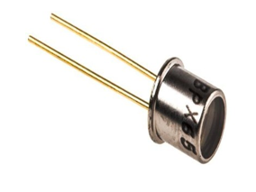v

**Fig2.3:** BPX65

1. **LED3MM:** A light-emitting diode is a semiconductor device that emits light when current flows through it. Electrons in the semiconductor recombine with electron holes, releasing energy in the form of photons. 3mm LEDs are the smallest and used in tight-fitting applications.

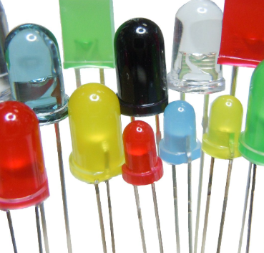

**Fig 2.4:** LED3MM

1. **LMV358MM:** The LM358 is a low-power dual operational amplifier integrated circuit. It supports an operating voltage of +3 to +32 volts (single power supply) or ±1.5 to ±16 volts (dual power supplies).Input voltage can range from −0.3 to +32 volts with single power supply. Small negative input voltages below ground are acceptable because the bipolar junction transistors at the input stage are configured such that their base-emitter junction voltage provides just enough voltage differential between the collector and base for the transistors to function.

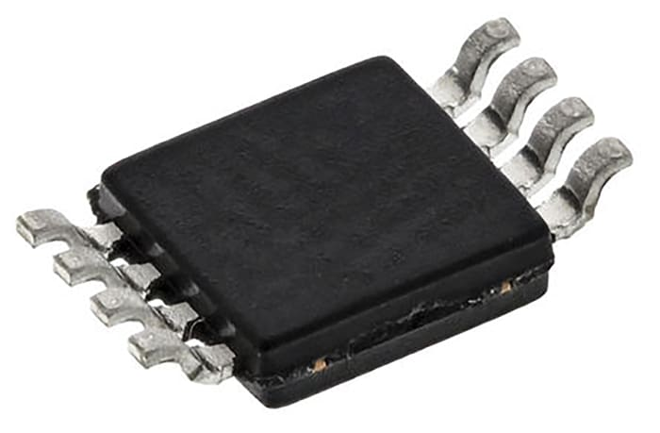

**Fig 2.5:** LMV358MM

1. **MTA02-100:** MTA 100 connectors provide both wire-to-board and wire-to-wire systems based on insulation displacement contact (IDC) technology. These connectors offer .100” [2.54mm] centreline spacing while still allowing for up to 28 positions. The connectors offer numerous options including colored housings and various types of plated contacts to offer solutions for a multitude of diverse applications.

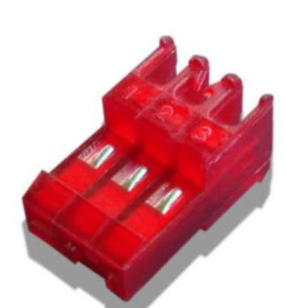

**Fig 2.6:** MTA02-100

1. **PT-10:** Piher PT-10 Carbon Potentiometers feature a carbon resistive element and polyester substrate in a dust-proof enclosure with life up to 10,000 cycles. The PT-10 potentiometers operate where frequent adjustment is required, and control variable outputs including frequency, motor speed, and volume.

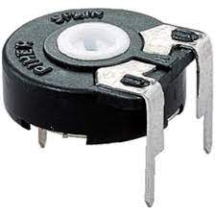

**Fig 2.7:** PT-10

**Schematic Diagram:**

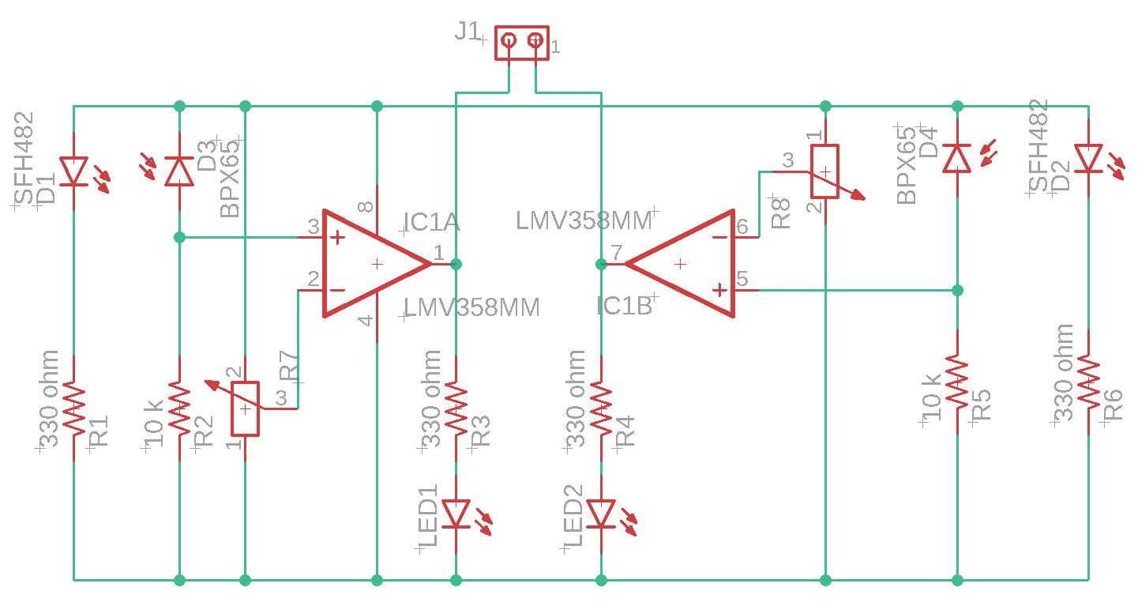

**Printed Circuit Board Layout:**

**Discussion:**

In this experiment, we successfully made a schematic diagram and a PCB layout of the IR sensor module circuit using CAD tools (Eagle Software).

We also learned the importance of various components used for making the IR module such as SFH482, BPX65, PT-10, LMV358MM, MTA02-100, etc. IR sensor is very important module for the “Buggy” project. This module is used for moving the buggy on a predefined path.

**Signature of Faculty member**